Terrafrom challenges
- Create an EC2 Instance on AWS Cloud using the below-mentioned ubuntu AMI and instance_type. Or, (You can use of your choice as well) ami = "ami-0461b1436c9b3c1a3" instance_type = "t2.micro"
Lets create a folder called aws_instance and create a file called main.tf
provider "aws" {
region = "ap-south-1" # Change if needed
}

resource "aws_instance" "web" {
ami = "ami-0461b1436c9b3c1a3"
instance_type = "t2.micro"

tags = {
Name = "Terraform-EC2"
}
}
Aws_instance main.tf

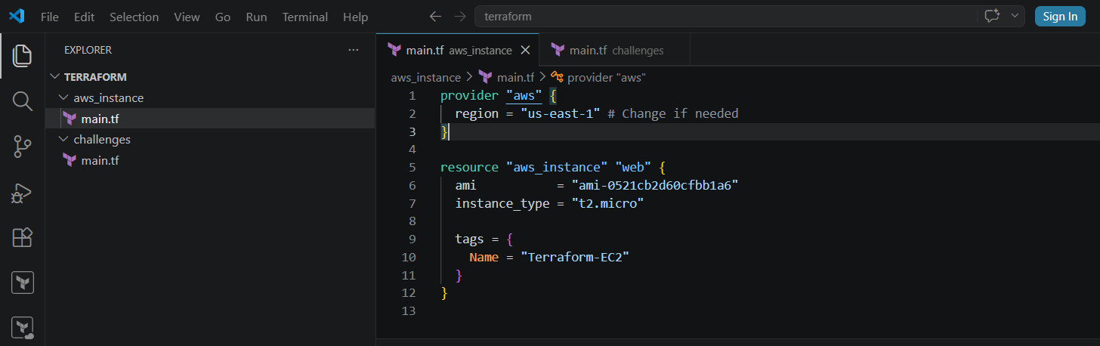
Lets create a folder called challenge and create a file called main.tf
provider "aws" {
region = "us-east-1"
}

resource "aws_instance" "ec2" {
ami = "ami-0461b1436c9b3c1a3"
instance_type = "t2.micro"
subnet_id = "subnet-xxxxxxxxxxxxxxxxx" # Replace with your subnet ID
associate_public_ip_address = true

tags = {
Name = "Terraform-EC2"
}
}
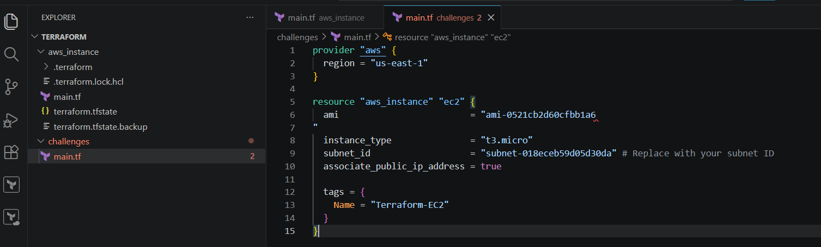
Terraform init
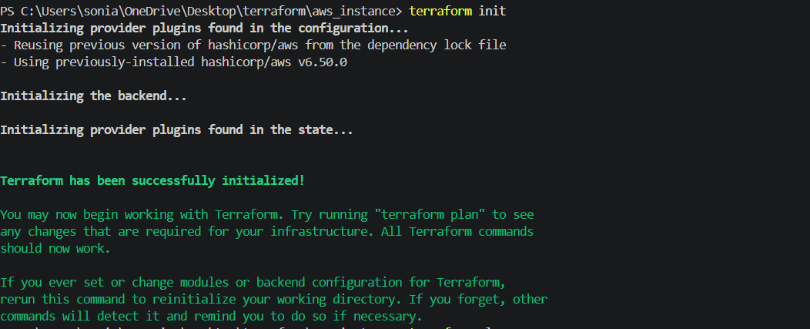
Terraform plan
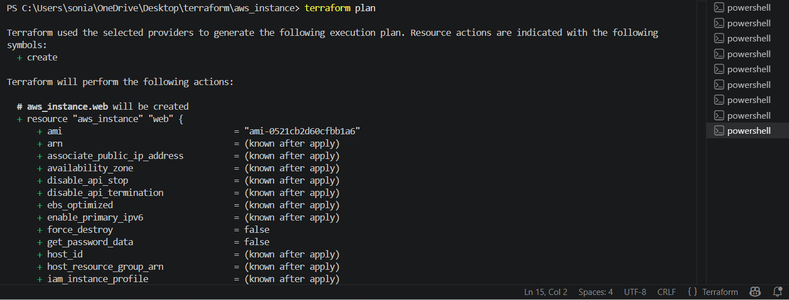
Terraform apply
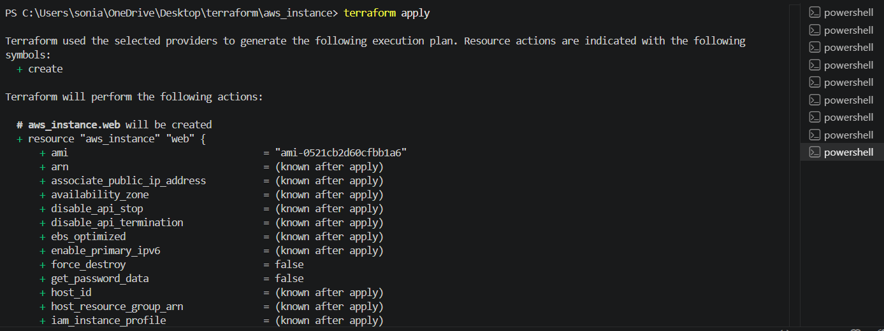
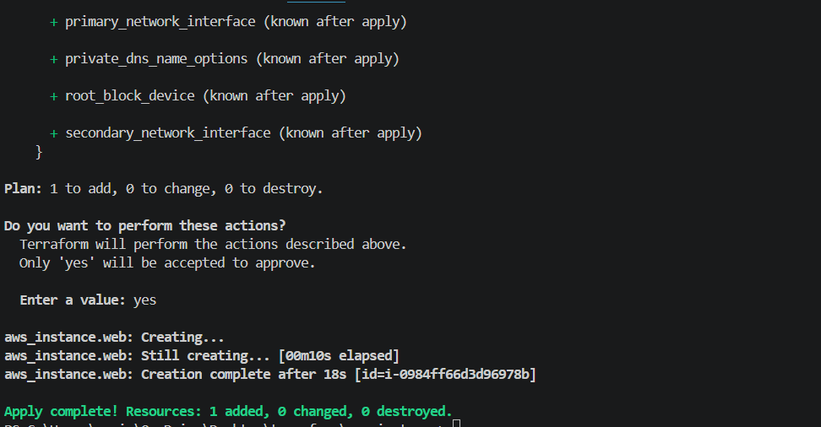
Confirm in AWSsuccessfully has been instance created
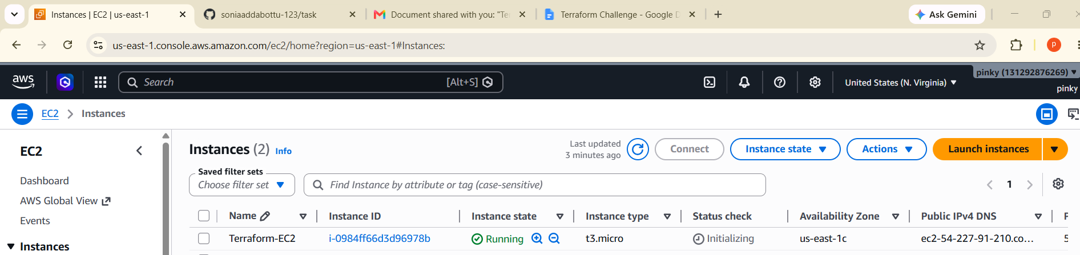

- Install a web server on the same EC2 Instance. The web server should listen on port 8080.
In the same main.tf file which we create earlier we are going to add a resource block for security groups and we will create and user data for installing nginx while creating a ec2 instance
resource "aws_security_group" "web_sg" {
name = "web-security-group"

ingress {
description = "SSH Access"
from_port = 22
to_port = 22
protocol = "tcp"
cidr_blocks = ["0.0.0.0/0"]
}

ingress {
description = "Web Server Port"
from_port = 8080
to_port = 8080
protocol = "tcp"
cidr_blocks = ["0.0.0.0/0"]
}

egress {
from_port = 0
to_port = 0
protocol = "-1"
cidr_blocks = ["0.0.0.0/0"]
}
}
resource "aws_instance" "ec2" {
ami = "ami-0521cb2d60cfbb1a6"
instance_type = "t3.micro"
subnet_id = "subnet-018eceb59d05d30da"
associate_public_ip_address = true

vpc_security_group_ids = [aws_security_group.web_sg.id]
user_data = <<-EOF
#!/bin/bash

dnf update -y
dnf install nginx -y

cat > /usr/share/nginx/html/index.html <<HTML
<h1>Nginx Running on Port 8080</h1>
HTML

cat > /etc/nginx/conf.d/web.conf <<NGINX
server {
listen 8080;
server_name _;
root /usr/share/nginx/html;
index index.html;
}
NGINX

systemctl enable nginx
systemctl restart nginx
EOF
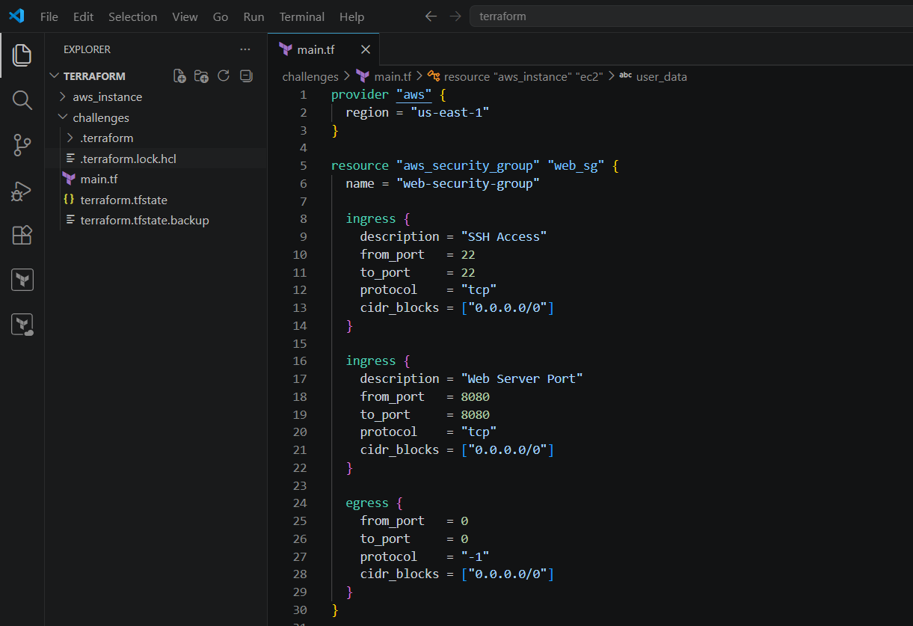
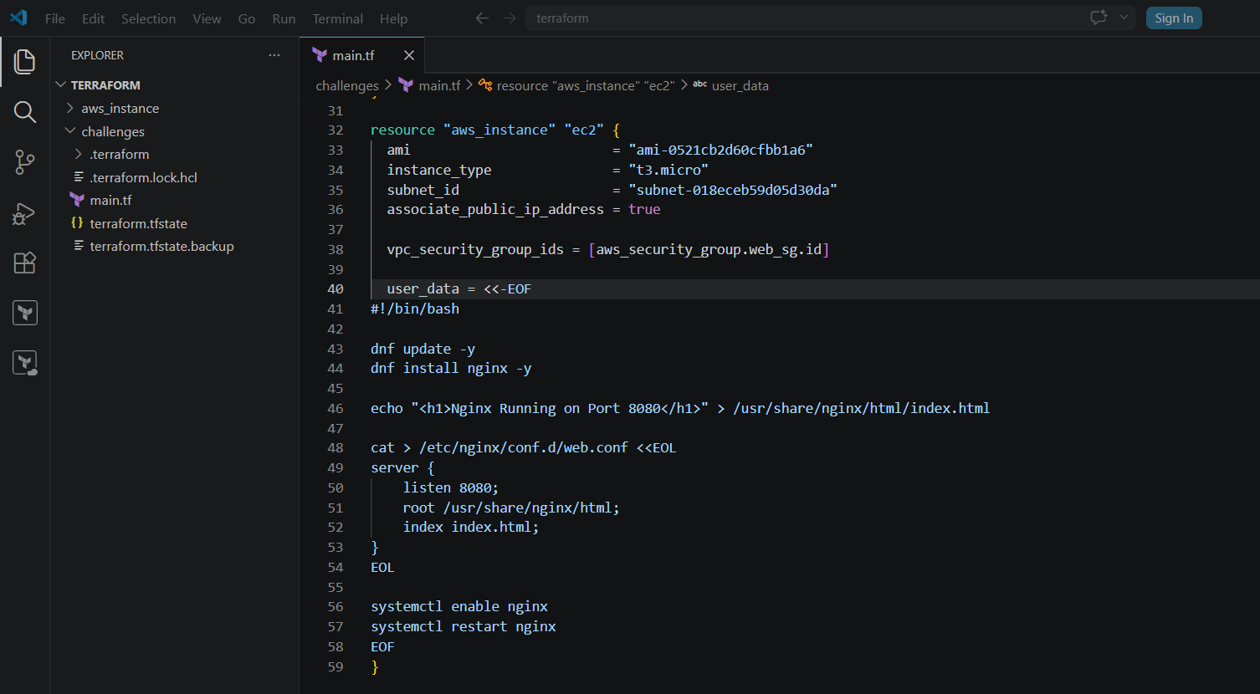
Terraform init
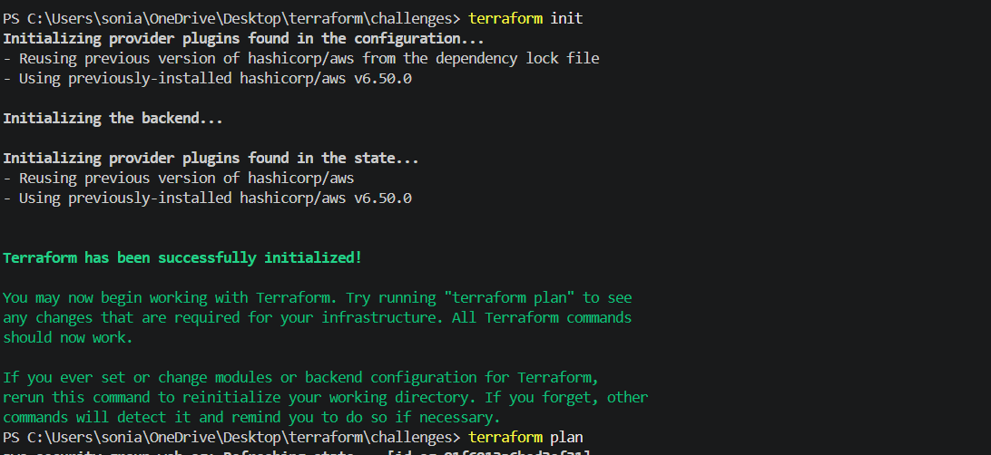
Im trying to nginx server is not found because perform the terraform destroy
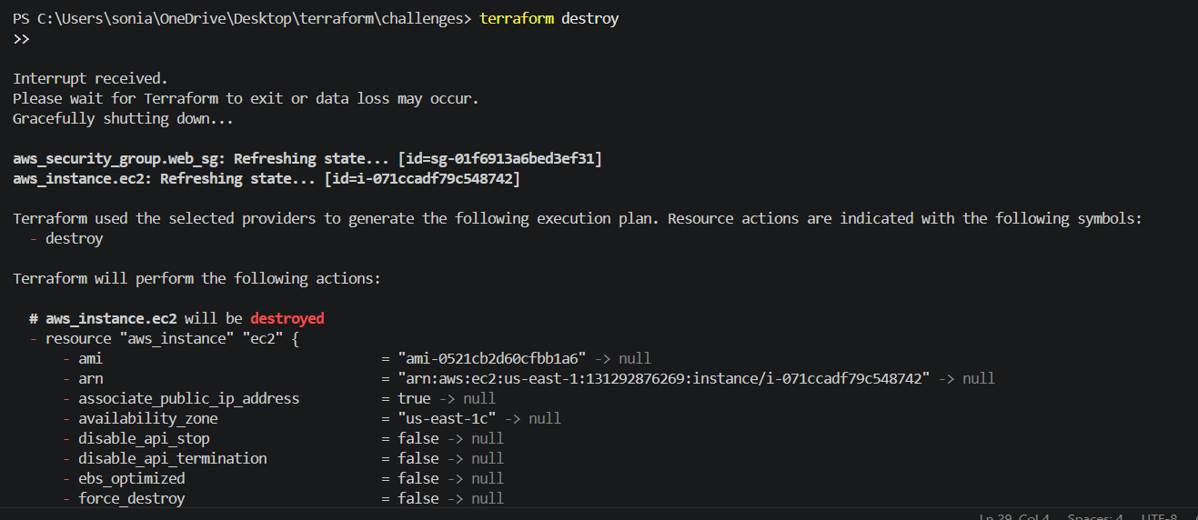
Terraform apply
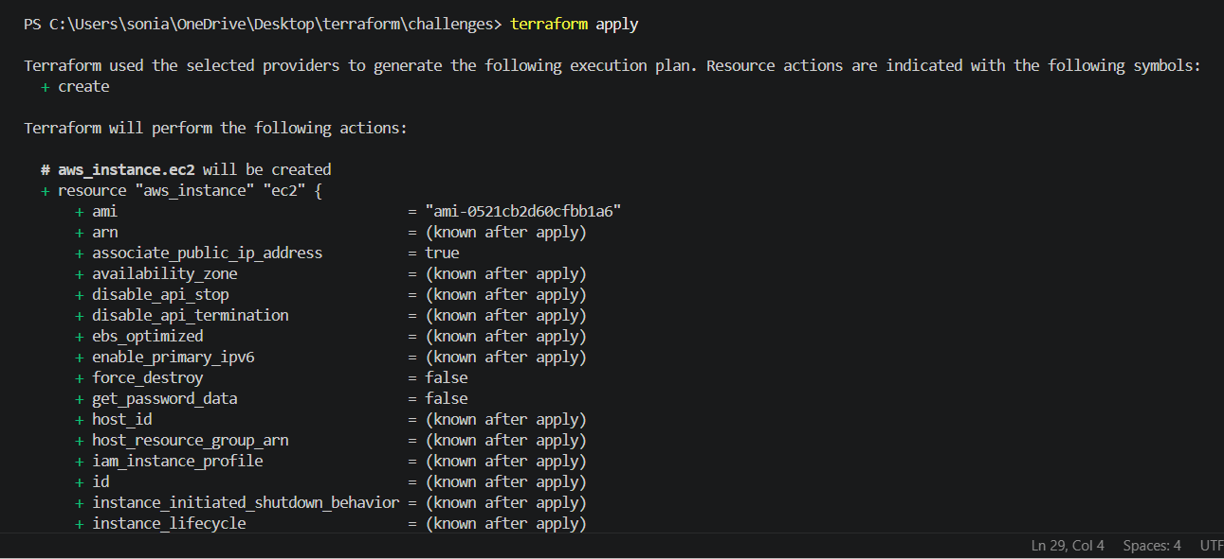
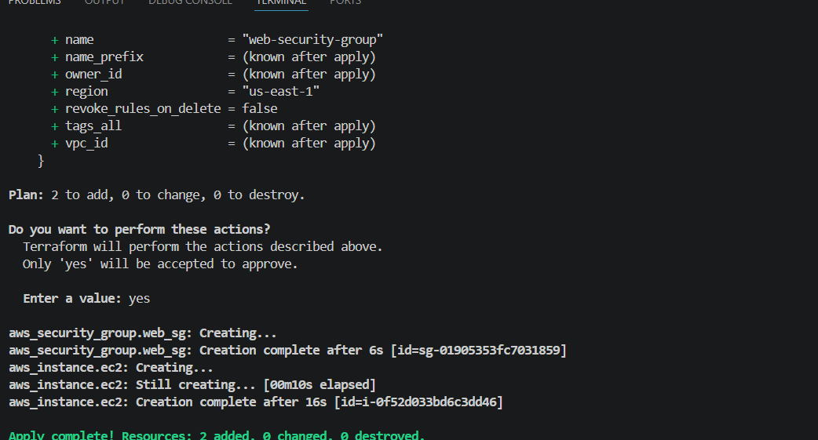
When we check ec2 has been created
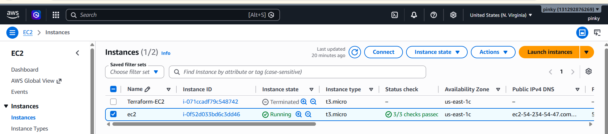
Lets check by connecting
Systemctl status nginx
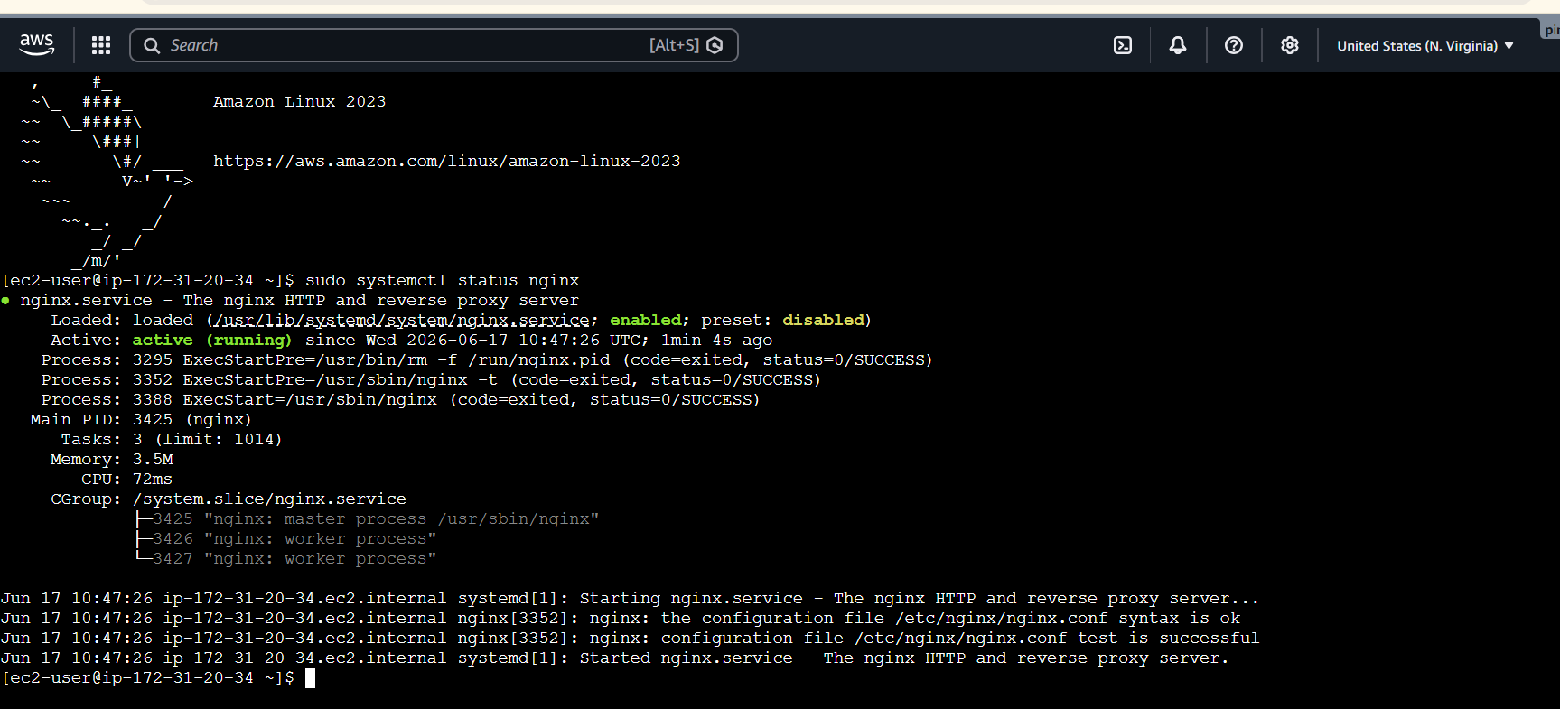
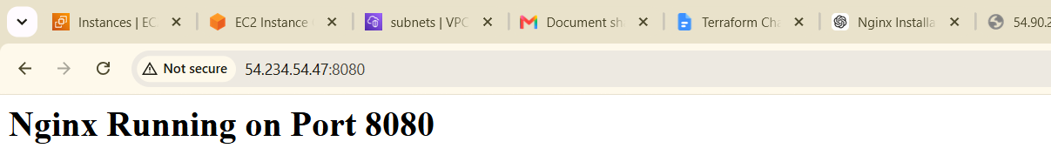

- Create a Docker-compose file for the project:https://github.com/betawins/cricbuzz-docker-hello-world.gitand point it to port 8000.
- Make the web server point to the above service so that 8080 returns the response from the Docker service.
First create main.tf file
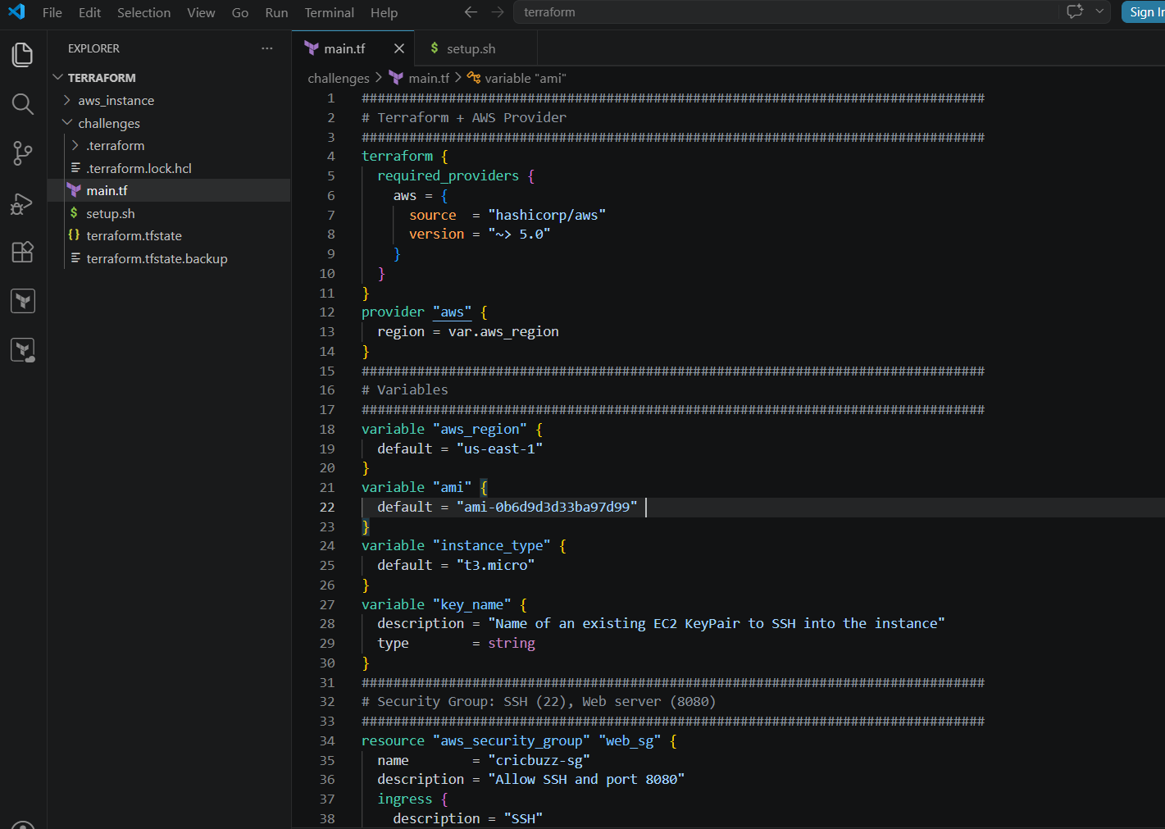
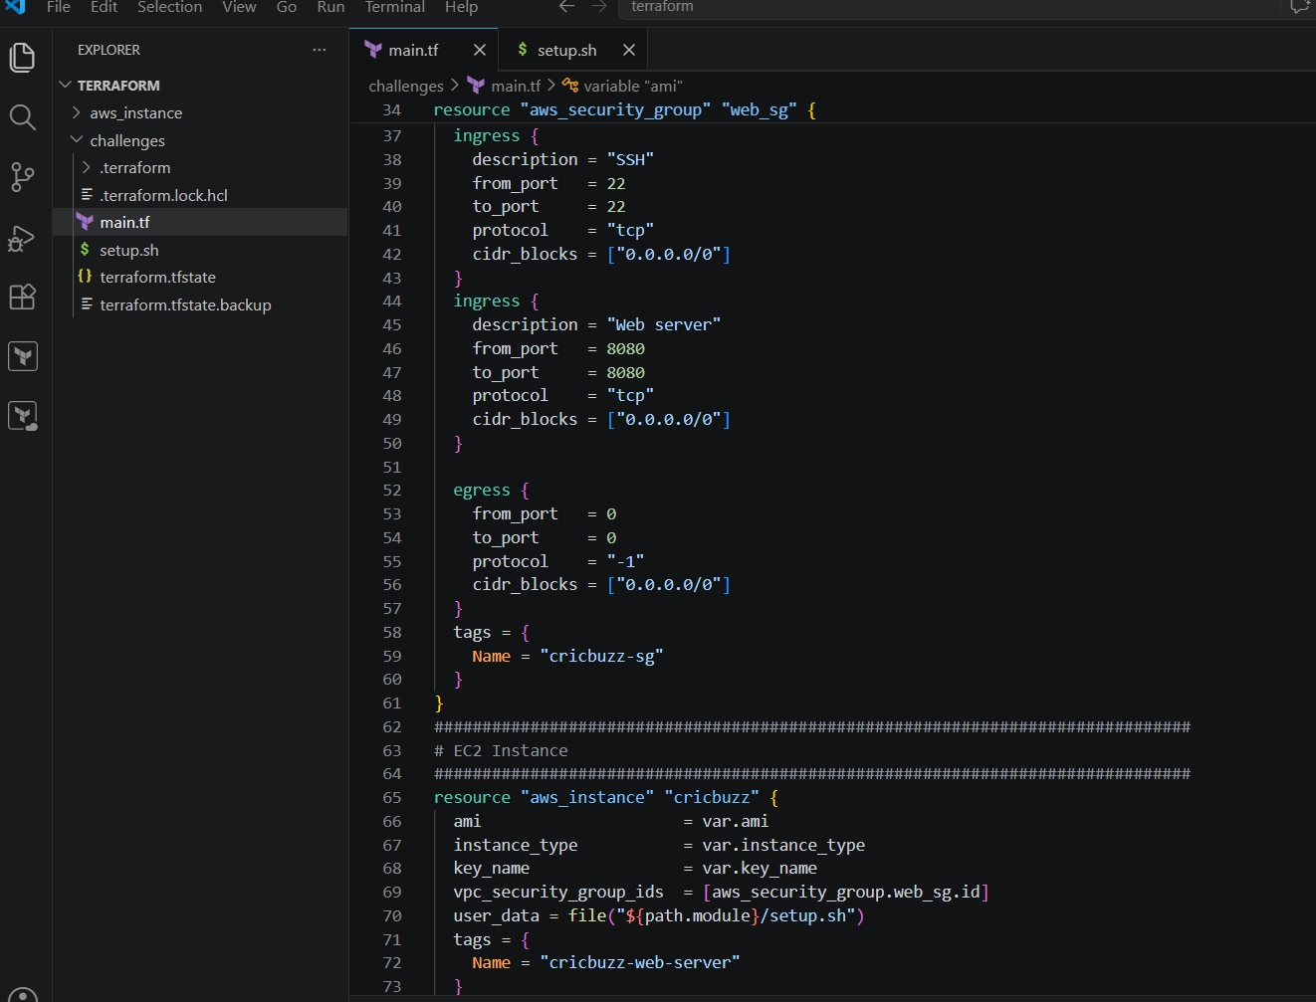
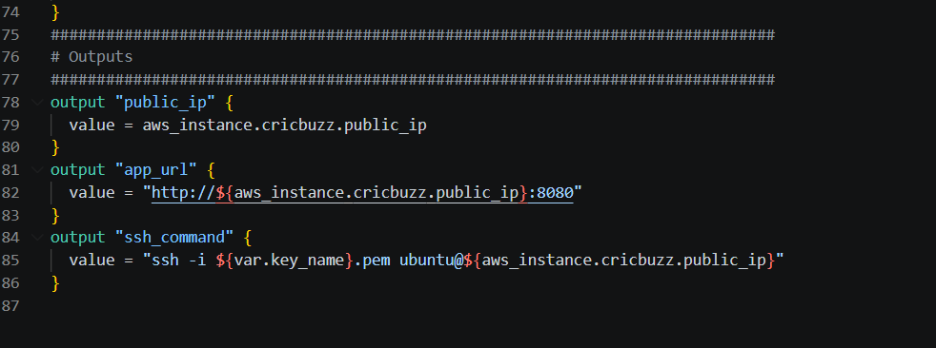
Lets create Setup.tf
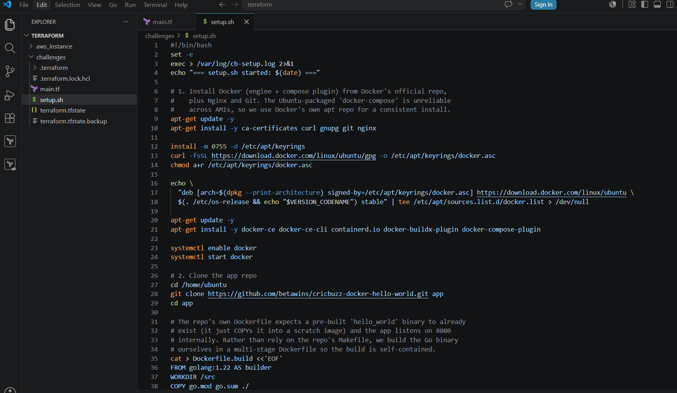
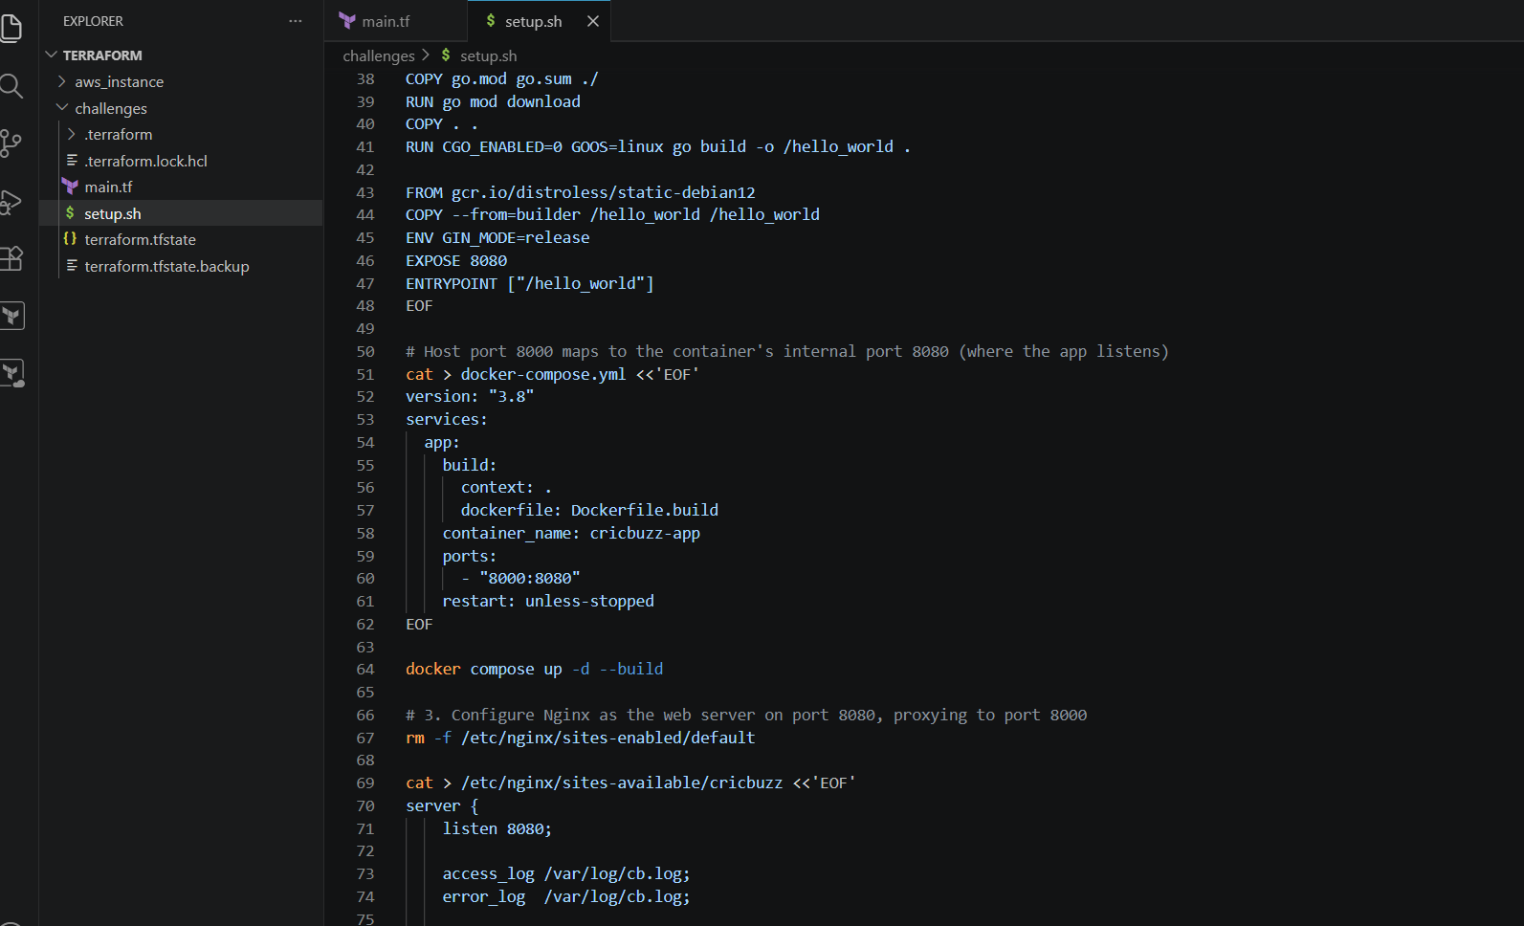
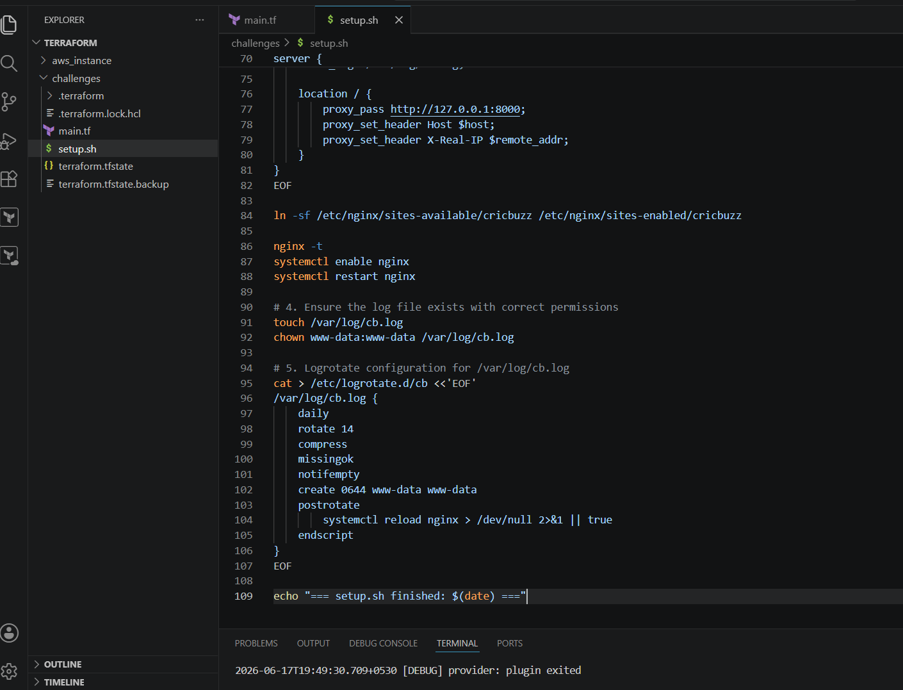
Terraform init,terraform plan,terraform apply
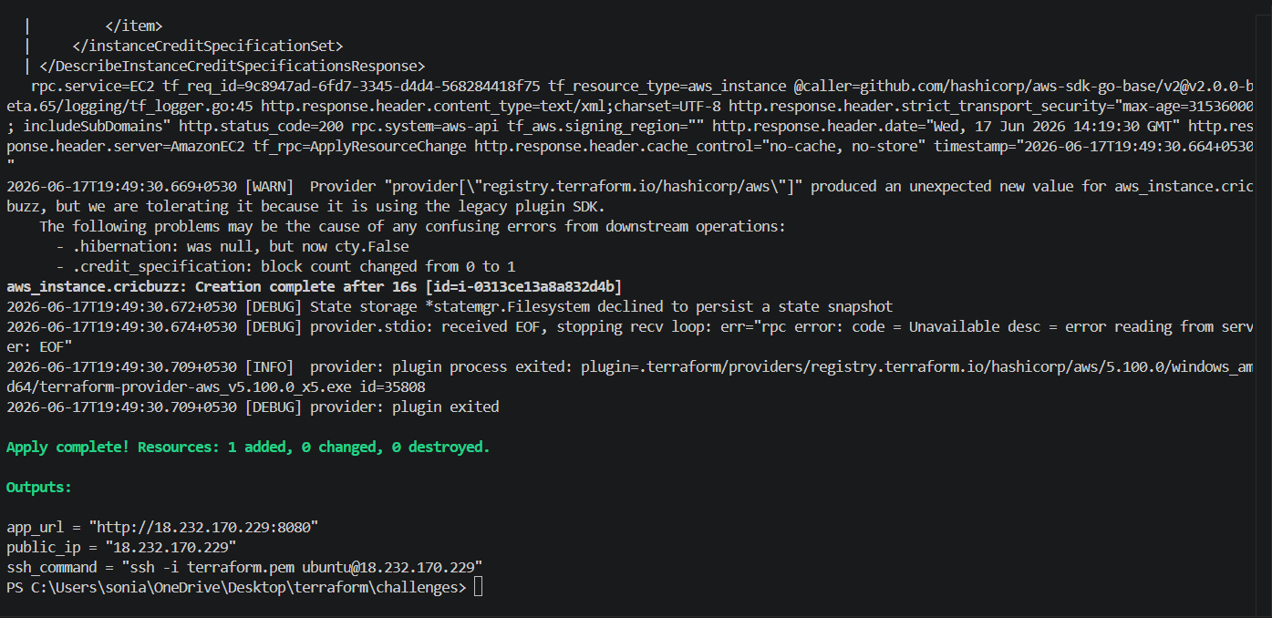
We check ec2 is created
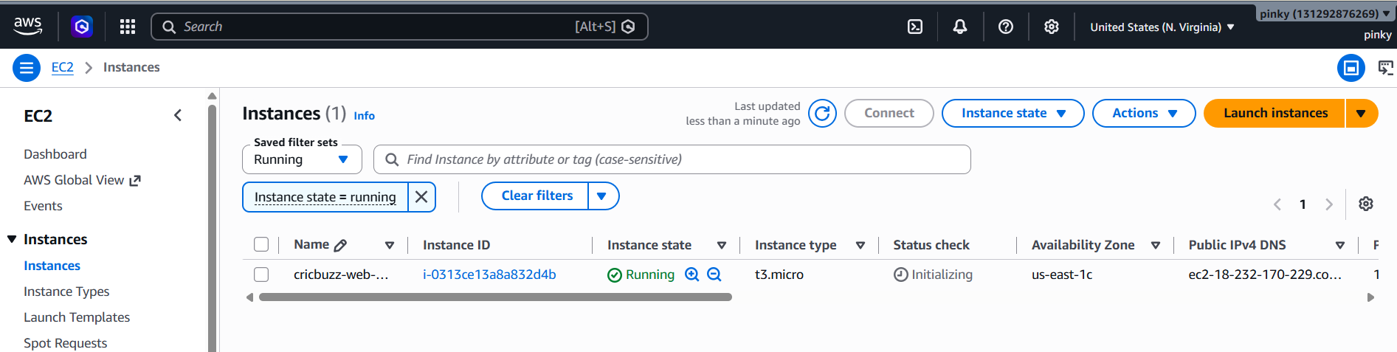
Verify the browser
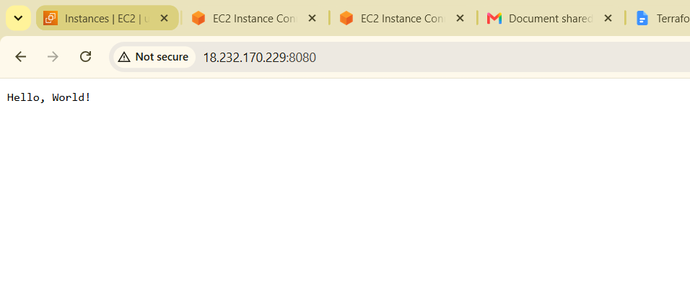
- Configure to Save the Logs in the location /var/log/cb.log
- Write the Log rotate configuration for the above file
we are able to see the logs
First Change the directorycd /var/logls
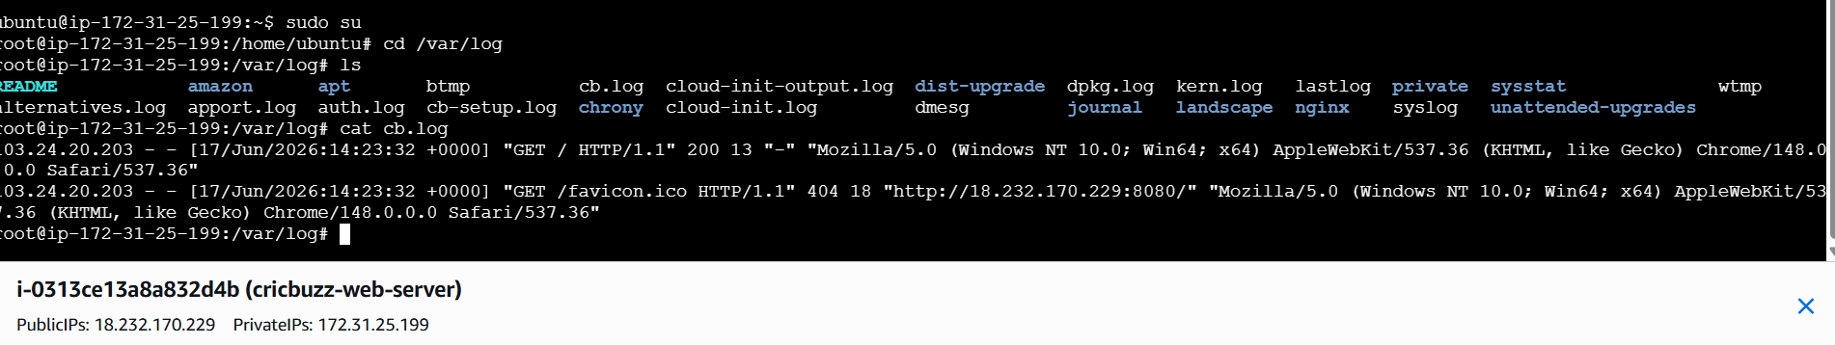
Change the directory
Cd /etcls
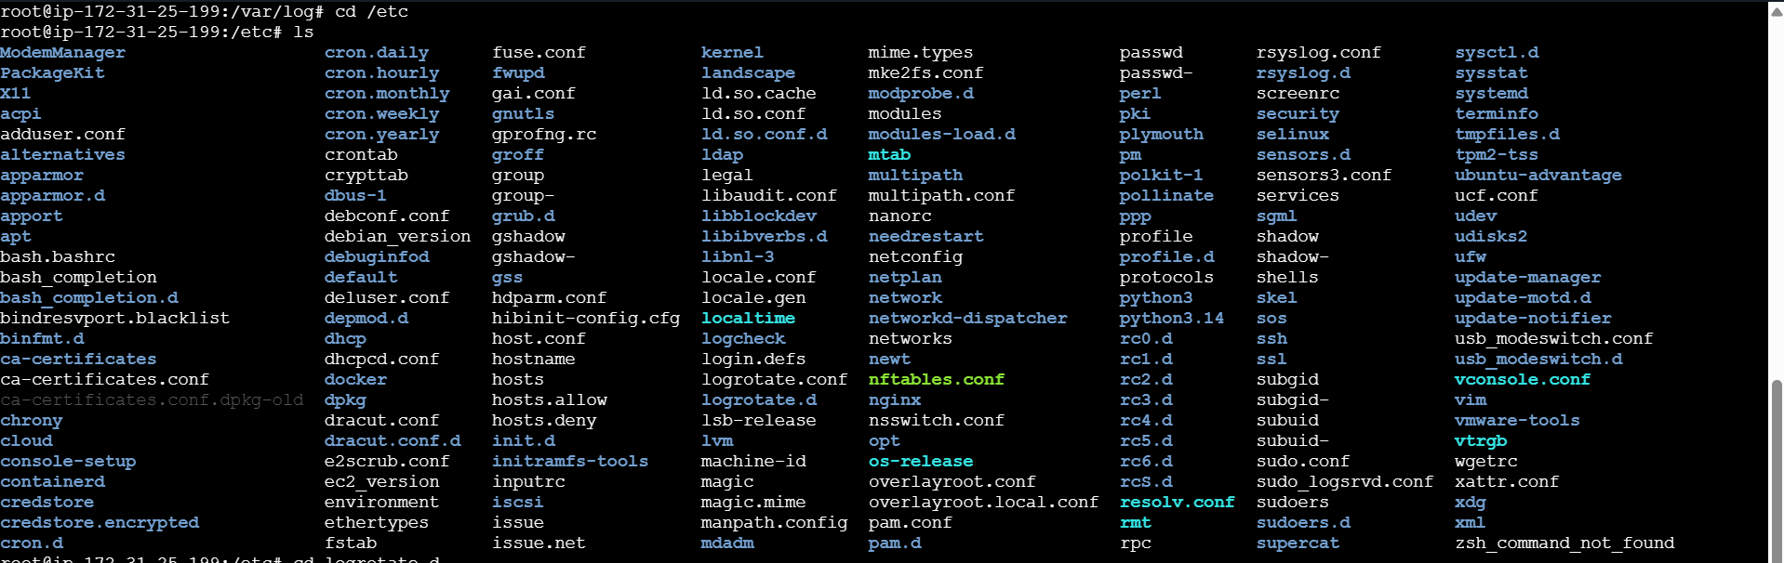
Cd logrotate.d
Cat cd
